HappyCo’s Data Analysis

Arit Akpan

Eduardo Manotas

Julia Saaverda

Lillian Townley

Esin Bilgin Savkli

Algonquin College - Business Intelligence System Infrastructure

Data Modeling - 24W_CST2205_010

08/04/2024

**Contents**

Executive Summary 3

Objective 3

Problem Statement 3

Methodology 3

Key Findings 3

Conclusion 3

Recommendations and Suggestions 3

Assumptions 4

Analysis 5

Sales Management 5

Order Processing 6

Shipment Monitoring 8

Employee Performance Review 9

Inventory Management 11

Conclusion 13

Recommendations and Suggestions 13

References 14

# Executive Summary

## Objective

HappyCo aims to strengthen its market position and boost sales within the competitive e-commerce sector. The objective focuses on leveraging digital innovation and operational optimization to surpass customer expectations and drive growth.

## Problem Statement

HappyCo needs to analyze its performance over the last three years to identify strengths, areas for improvement, and growth opportunities. This analysis will inform strategies to enhance operational efficiency, customer satisfaction, and sales, securing HappyCo's success in the online marketplace.

## Methodology

In the methodology, a cohesive approach was employed, beginning with draw.io for initial data modeling to create visual representations of each business process. Subsequently, Power BI and Power Query were utilized for the practical implementation and refinement of these models. Power Query facilitated the ingestion, cleansing, and transformation of data, while Power BI was instrumental in unifying the individual business process models into a comprehensive analytical framework. This unified model served as the basis for data visualization efforts, employing Power BI’s advanced data-analysis tools, AI capabilities, and user-friendly report-creation features to transform data into insightful visuals that underpin the findings and recommendations. [1]

## Key Findings

Analysis of HappyCo's last three years highlights a loyal customer base across the low to middle-income segments, with Cleats, Men's Footwear, and Women's Apparel as top sellers. A revenue drops in Q4 2017, due to stock shortages, underscores the need for better inventory management. Additionally, 57% of orders were late, mainly standard deliveries, suggesting delivery process improvements are needed. The data also shows top-performing employees concentrated in specific departments, indicating potential overwork and the need for staff adjustments. These insights suggest prioritizing customer satisfaction, inventory accuracy, and operational efficiency to drive HappyCo's market position and sales growth.

## Conclusion

In conclusion, the analysis of HappyCo's operations and performance data over the past three years reveals significant opportunities for improving customer satisfaction, optimizing inventory management, and enhancing overall operational efficiency. Key to achieving these improvements will be addressing identified challenges in product stock shortages, delivery delays, and employee workload distribution.

## Recommendations and Suggestions

To bolster HappyCo's market presence and sales, it is recommended to scale up leading categories, broaden the product range with fresh SKUs, and enlarge the customer base in the Pacific region. Enhancing delivery reliability and aligning inventory with sales trends are also critical for meeting customer expectations and supporting business growth.

# Assumptions

In the analysis and formulation of strategic recommendations for HappyCo, the following assumption regarding data integrity was critical:

Data Integrity: It is assumed that the dataset from Kaggle, utilized for the analysis, was structurally sound and reflective of HappyCo's business operations. However, it is essential to note that the dataset did not originally contain employee data. For the purposes of this project, employee data was generated using Python, following a set of rules to maintain consistency with realistic business scenarios. Each employee was assigned to a department involved in overseeing orders, and provided with a review, salary, and number of hours worked, all randomized within plausible ranges. Although this synthetic data is not derived from actual operations, it is adequate for the objective of data modeling and analysis within this project.

This assumption ensures that the conclusions and strategic recommendations are based on a dataset that is believed to be a reasonable proxy for HappyCo’s actual operations, acknowledging the limitations presented by the generated nature of the employee data.

# Analysis

The analysis focused on five key business processes crucial to HappyCo's operations, leveraging the combined datasets to understand and optimize each aspect:

## Sales Management

HappyCo has exhibited minimal variations in sales over the last three years, maintaining robust revenue of 10.7 million USD and offering a consistent 10% average discount. This demonstrates the company's strong market positioning and the effectiveness of its pricing strategy.

The analysis of product performance indicates a significant concentration of sales within the top 10 products. This finding suggests a strategic opportunity to not only concentrate efforts on these high-performing products but also to dissect the reasons for their success and apply these insights to other product lines.

Segmentation analysis has also shed light on customer behavior, revealing distinct segments with varying engagement levels and conversion rates. These insights are crucial for refining customer relationship management and developing targeted marketing campaigns.

**Figure 1: Storytelling though dashboard – Sales Process**A screenshot of a computer

Description automatically generated

Moreover, the utilization of waterfall charts allows for a detailed examination of year-over-year sales variations. This approach has identified critical areas requiring attention, such as the 0.28 million USD sales drop in the fourth quarter, which was found to be due to inventory constraints that impacted growth. These analytical tools have been invaluable in pinpointing issues and opportunities for HappyCo's future growth strategies. It can be seen in Figure 2.

**Figure 2: Order Item Total**

## Order Processing

The thorough analysis of HappyCo's order process, spanning from 2015 to 2017, highlights a nuanced relationship between customer spending habits and inventory control, both central to the company's revenue trends. A notable trend observed is the increase in average spend per order during weekends, suggesting a customer inclination towards larger purchases outside standard workdays. This could indicate a pattern of recreational spending or the success of weekend-specific promotions. To illustrate this pattern more vividly, we can examine a line graph comparing the average spend per order between weekdays and weekends over this three-year period. Figure 3 showcases the fluctuations and trends in consumer spending behavior.

**Figure 3:** **Comparative Spend Analysis: Weekday vs. Weekend Orders (2015-2017)**

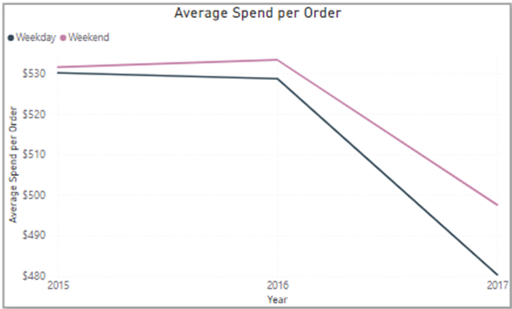

Analyzing HappyCo's customer demographics reveals insightful details about the consistent volume and segmentation of its customer base. With Consumer (51.79%), Corporate (30.21%), and Home Office (18%) segments, the data underscores the significant dominance of the Consumer segment, which makes up more than half of the clientele. This demographic distribution highlights HappyCo's widespread appeal and its established presence in the retail sports market.

Additionally, the review of HappyCo's order volumes for its top-selling categories over the past three years, as depicted in the "Top 3 Selling Product Category" chart, shows a notable decrease across all categories in 2017. Cleats, Indoor/Outdoor Games, and Women's Apparel, traditionally the mainstays of HappyCo's sales and indicative of the company's capacity to meet consumer trends and demands, experienced a concurrent drop in order quantities. This decline across such key categories suggests the possibility of a broader market issue or an internal challenge affecting product availability or consumer demand within HappyCo's operational strategies in 2017.

**Figure 4:** **Top 3 Selling Product Category by Order Quantity**

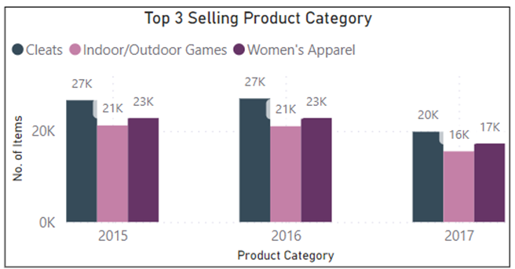

The decline pattern is further validated by the "Revenue by Years, Quarter & Month" chart, revealing a significant dip in the final quarter of 2017. The combined analysis of revenue and order quantity charts indicates a correlation between the drop in orders for best-selling products and the overall revenue reduction. The pronounced revenue decrease in Q4 2017, coinciding with fewer orders, suggests that stock shortages may have significantly affected sales.

**Figure 5: Revenue by Years, Quarter & Month**

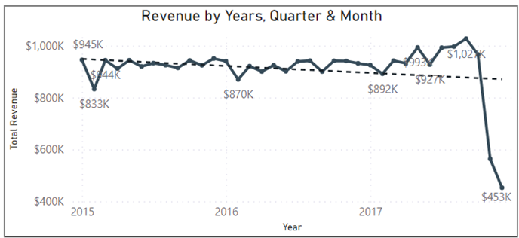

This situation highlights inventory management as a pivotal concern. The shortfall in stock levels, particularly for high-demand items, likely led to the revenue downturn, emphasizing the need for effective inventory planning and supply chain flexibility. For HappyCo, it's crucial to delve into the causes of the consistent order reduction and its revenue effects. Insights gained from this analysis will inform strategic enhancements in inventory controls, product mix optimization, and marketing strategies aligned with observed purchasing patterns.

Looking ahead, HappyCo should leverage these analytical findings to avoid a repeat of the 2017 sales decline and fortify its market presence. Such measures will not only help the company recoup previous losses but also enhance its adaptability to market shifts. Despite having a loyal customer base and steady sales in key categories, prioritizing inventory management improvements and capitalizing on consumer spending insights are essential for HappyCo.

## Shipment Monitoring

Analyzing the shipping performance dashboard for HappyCo over the last three years reveals that the company is facing a significant challenge with timely deliveries: 57% of shipments have not been delivered on schedule, with the majority being standard class shipping. This is a critical area for improvement, as on-time delivery is a crucial factor in customer satisfaction and loyalty, which in turn can significantly influence sales.

Standard class shipping, the most common shipping method among late deliveries, might need a thorough process review to pinpoint inefficiencies or delays in the system. Investigating the reasons behind these delays could involve looking at warehouse operations, carrier performance, and even the accuracy of delivery estimates provided to customers. It's also worth examining whether the current distribution of shipping methods aligns with the expectations and preferences of HappyCo's customer base. Improving the on-time delivery rate is likely to enhance customer satisfaction, encouraging repeat business and positive word-of-mouth, which are invaluable for company growth. Addressing this issue will require a strategic overhaul of the current shipping processes and possibly renegotiating terms with shipping partners or exploring alternative logistic solutions to improve performance.

**Figure 6: Shipment process**

## Employee Performance Review

Through the analysis of HappyCo's employee review process from 2015 to 2017, we gain insights into improving sales by empowering employees. It's critical to understand each employee's contribution to HappyCo's sales success and how trends among employees affect the number of orders they manage.

Before delving deeper into this analysis, it's important to reiterate that the data was artificially generated. This means trends in the data may not be deliberately created and, consequently, may not reflect real-world patterns. For instance, this dataset shows no correlation between training, wages, and employees' KPIs, a trend typically presents in genuine company data. An effort was made to ensure this data approximates real-world averages.

The dashboard review is crucial as it displays data and illustrates how it can be aggregated. The three KPIs for the employee review process are average job involvement, job satisfaction, and performance rating. Job involvement measures an employee's engagement, satisfaction reflects their contentment with their job, and performance rating is the employer's assessment of their work. [2]

The "Number of Employees by Department" graph informs us of the staffing levels in each department, indicating potential areas of understaffing or overstaffing. "Number of Orders by Employees" ranks employees by their order management productivity.

At the dashboard's bottom, we see each employee's yearly wage, hours worked last year, and training hours—all vital for evaluating performance.

The dashboard's top allows data aggregation by order status, department, gender, and time, facilitating analyses like the one conducted in this project, focusing on data from 2015 to 2017.

**Figure 7: Employee Review Process**

In Figure 8, focusing solely on the footwear department, we observe that its employees have more sales than those in any other department, yet it has the fewest employees. This suggests the footwear department is critically understaffed. Hiring new staff or reallocating staff from better-staffed departments could boost productivity and sales.

Alternatively, the fan shop department, with the most employees, is the second most overworked, indicated by the high number of orders per employee. While the situation is less critical than in footwear, similar measures may enhance efficiency and sales.

**Figure 8: Footwork Department – Employee Review Process**

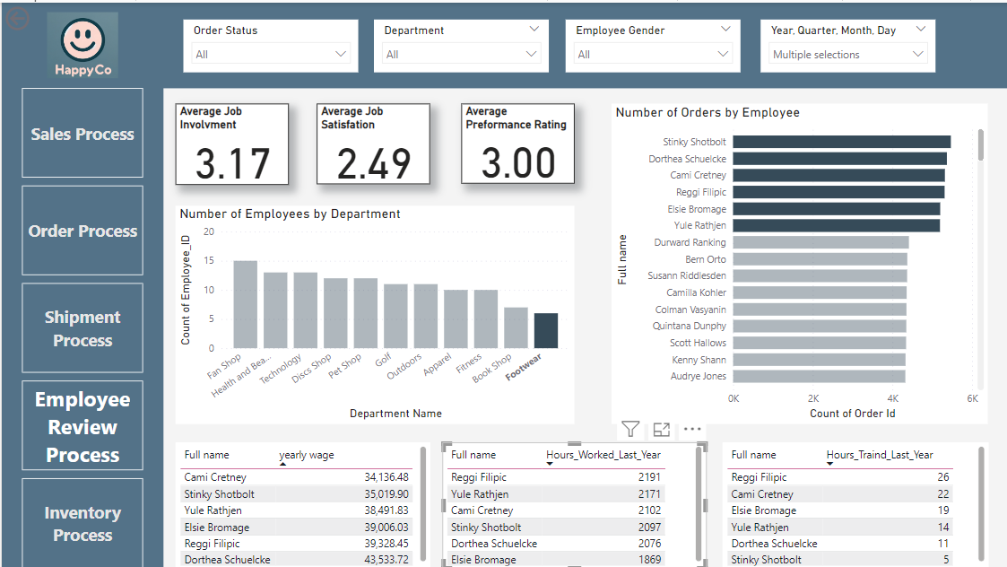

Investigating additional aspects of HappyCo's employee performance could yield productive insights if the data were real. For instance, significant shifts in average employee KPIs when analyzed by gender could point to potential issues of sexism within the company. Employees facing discrimination might underperform compared to their potential in an unbiased environment. Another example would be exploring the relationship between the number of orders handled and the hours dedicated to training. While such correlations are absent in this synthetic dataset, they could inform recommendations on adjusting training hours in a real-world setting.

Turning to the top-performing employee in each department, as depicted in figure 9, we aim to discern whether KPIs positively influence sales. However, the current analysis, limited by the artificial nature of the data, shows no clear correlation between high sales performance and favorable employee reviews. If this lack of correlation were observed in an actual company, it would warrant a thorough review of the employee evaluation process to determine its effectiveness and potential areas for enhancement.

**Figure 9: Footwork Department – Employee Review Process**

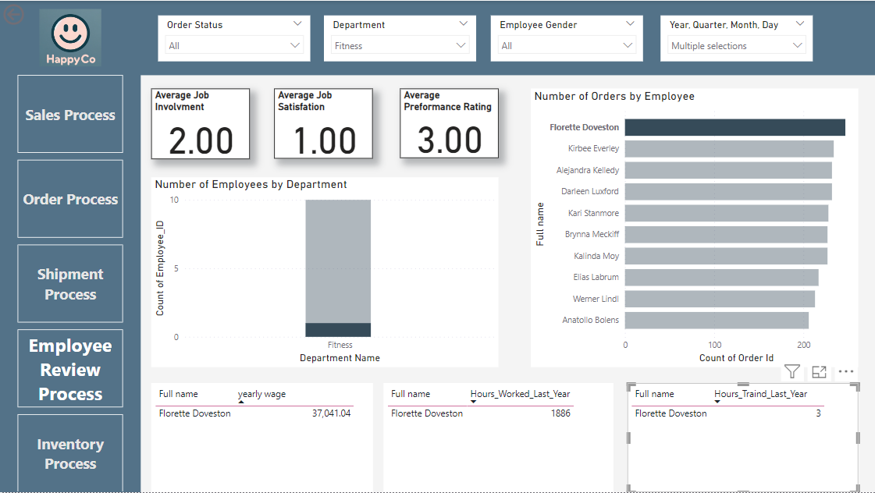

## Inventory Management

Efficient inventory management is pivotal for meeting customer demand and optimizing internal processes. HappyCo employs a dimensional model to structure data, facilitating valuable insights for informed and strategic decisions regarding inventory management.

Unique Identity for Products: Each product is assigned a unique ID, defining its distinct characteristics. This systematization, including name and category, ensures straightforward tracking.

Specifics of the Order: By analyzing order statuses, we can effectively manage the lifecycle of each order, thereby enhancing the customer experience.

Precise Location: Products are linked to specific locations via an ID that includes geographic details such as city, region, and country. This precise information aids in optimizing product distribution and delivery logistics.

Integration of the Date Dimension: Through the analysis of daily, weekly, monthly, and yearly sales and inventory data, we identify seasonal patterns, demand trends, and opportunities for improvement.

Detailed Record in the "Inventory" Fact Table: For a comprehensive inventory analysis, simply knowing the quantity on hand is insufficient. It must be contextualized with additional facts to measure inventory movement velocity and develop other insightful metrics. Thus, HappyCo’s inventory fact table encompasses details like product ID, order status, order date, quantity sold, unit price, and transaction total, enabling detailed sales analysis, inventory availability assessment, inventory turnover, and operational efficiency evaluation.

HappyCo began with an inventory of 601,000 units across 50 categories and 118 products. From 2015 to 2017, the company sold or committed 382,000 units, averaging 127,000 units per year. Given the current inventory, the average per category stands at 4,380 units, highlighting categories like Accessories, Golf Balls, and Girls Apparel as below this average and in need of closer monitoring to prevent stock shortages. Similarly, the average per product is 1,855 units, with products like Children's Heaters and Web Cameras marked as below average, indicating a need for increased attention to avoid inventory depletion.

**Figure 10: Storytelling though dashboard – Inventory Process**

# 

# Conclusion

The comprehensive analysis of HappyCo's operational data from 2015 to 2017 reveals significant insights into customer behavior, sales trends, and inventory management, presenting ample opportunities for enhancing overall operational efficiency. Despite facing challenges such as stock shortages leading to revenue drops in Q4 2017 and delays in order delivery, HappyCo has maintained a solid customer base and consistent sales performance in its core product categories. Addressing the identified issues particularly in inventory management, order processing efficiency, and employee workload distribution is crucial for improving customer satisfaction and sustaining HappyCo's growth and success in the competitive e-commerce landscape.

# Recommendations and Suggestions

It is recommended to prioritize the following strategic actions: Firstly, scale up the inventory for leading categories to mitigate stock shortages and capitalize on high-demand products. Secondly, introduce a range of new SKUs to diversify the product offering and cater to broader consumer preferences. Expanding the customer base in the Pacific region through targeted marketing strategies could unlock new growth avenues. Additionally, enhancing the reliability of delivery services and aligning inventory levels with sales trends will be key to meeting customer expectations and bolstering business growth. Implementing these recommendations will not only address the current operational challenges but also position HappyCo for robust performance and resilience against future market dynamics.

# References

[1] Microsoft, "Power BI," [Online]. Available: <https://www.microsoft.com/en-us/power-platform/products/power-bi>. [Accessed: Mar. 27, 2024].

[2] "How many work hours in a year (with steps to calculate them)," Indeed.com Canada, [Online]. Available: <https://ca.indeed.com/career-advice/career-development/how-many-work-hours-in-year>. [Accessed: Apr. 8, 2024].

[3] R. Kimball, M. Ross, W. Thornthwaite, J. Mundy, and B. Becker, *The Data Warehouse Toolkit:* The Definitive Guide to Dimensional Modeling, 3rd ed., was consulted for guidance. [Online]. Available: https://learning.oreilly.com/library/view/thedatawarehouse/9781118530801/9781118530801toc.xhtml [Accessed: 06-04-2024].

[4] "Handling MULTIPLE fact tables in Power BI" YouTube, uploaded by [Guy in a Cube], [Feb 10, 2021]. [Online]. Available: <https://www.youtube.com/watch?v=TnyRsO4NJPc>. [Viewed for guidance].

[5] Microsoft, "Transform and model data in Power BI," Microsoft Docs, [Online]. Available: <https://learn.microsoft.com/en-us/power-bi/transform-model>. [Consulted for information].